**Year 3 and 4**

**Spring Term 2 Curriculum**

**Cycle A**

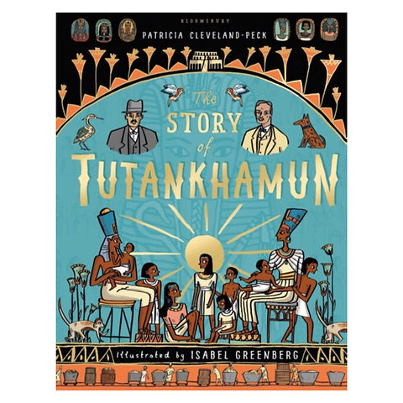

**Key Information:**

Teacher : Mrs Cumming-Bruce

TA: Mrs Murphy

Reading Records: checked on a Monday

Homework : Handed out on Wednesday, due in on Monday

PE days: Monday and Tuesday

**English:**

In English we will be reading ‘How The Whale Became and Other Stories’ by Ted Hughes, in which the children will be exploring the magical and wonderful ways in which animals became the way they are. They will go on to research their own animals and creating their own origin stories in the same style as Hughes. Following this we will move on to a text that is closely linked to our current History topic of Ancient Egypt – ‘The Story of Tutankhamun’. Whilst studying this book, we will be looking into biography writing and having a go at writing our own biographies.

For our guided reading sessions, also linked to our History topic, we will be looking at ‘The Humans’ by Jonny Marx – all about ancient civilisations and the astonishing things they taught us.

**Maths:**

Much of this term will be spent on the topic of Fractions. As there is a lot to unpack in this topic, we will work our way through gradually, starting with ordering unit and non-unit fractions, mixed numbers and improper fractions (for the Year 4 children), equivalent fractions and adding and subtracting fractions, touching briefly on decimals at the end of the topic. Alongside this there will be a continued focus on polishing our times tables.

**Science:**

Our science topic this half term is all about Flowers, Fruits and Seeds. We will look at the life cycle and parts of a flower, as well as learning about the importance of flowers, bees, fertilisation and the huge variety of fruits and seeds.

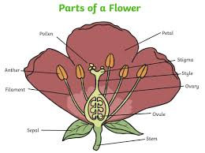

**Art**

In Art we will be studying the life and works of two artists – Barbara Hepworth and Joan Miro. The children will compare their styles, plan and design a cardboard sculpture in the style of Hepworth and paint a surrealist piece in the style of Miro.

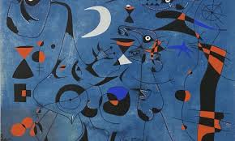

**History**

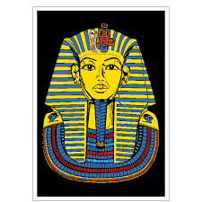

In History this term we will be studying Ancient Egypt. Many of our lessons will be mixed with Year 5 and 6 as they are covering the same topic, and will include learning about timelines, artefacts, and gods among other things. We will also have an Ancient Egyptian Day, when children will be able to dress up and immerse themselves in Ancient Egyptian culture.

**Computing**

This term’s Computing topic is Desktop Publishing, so the children will be given the opportunity to have a go at editing and formatting various presentations in different ways on the Chromebooks, as well as learning about how and why Desktop Publishing is used to the best effect.

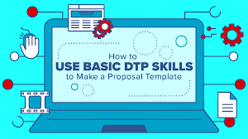

**PE**

On Mondays we will have a PE session where the children are trying various sports, and Tuesday morning sessions are Gymnastics in the school hall. Forest School will resume after the Easter Holidays.

**RE**

In our RE lessons this half term we will be learning about Lent and the Temptation of Jesus. We will study the story behind this topic, and think about why people may give things up and why it can be difficult to do so.

**PSHE**

In PSHE we will be looking at Citizenship; covering the themes of looking after the environment, community, rules and rights.

**French**

Mrs Gosling will be leading French sessions and the children will be covering the topic of

**How to help your child at home**

Your child should read every day at home. Hearing your child read aloud as much as possible and discussing what they have read really helps with their comprehension. Times tables practice is also brilliant for their maths. Please gently encourage them to complete homework, supporting when necessary, and if they are finding it difficult or taking a long time over it, I am happy to go through it with them in school. Spelling assignments will be set each week on Spelling Shed, coinciding with the spelling sound/rule they have been covering in school that week.